# **Aims and Objectives**

The Project’s primary purpose is to help the user to test the strategies of automated bots on the real time data of the stock with the help of the virtual money provided by the platform. So, the user doesn’t lose their real money testing or perfecting their strategies. He can find out the effectiveness of his strategies he came up without any risk of losing.

The motive for this project is there aren’t any open-source applications available for the users and as a beginner trader this would help a lot. Since the era of stocks, the retail traders were increasing day by day and not everybody know much about it. It was very interesting to help such kind.

Due to the scarcity of existing similar products, it is difficult to find references that would help the development of this very complex project.

# **Requirements**

The requirements or objectives are separated into essential, recommended, and optional.

**Essential:**

* Register – Registration page for the users.
* Login – Login page for the users.
* Authentication – Additional security for the users to login.
* Trade – Able to buy and sell the stocks.
* Portfolio – Display of the stock’s users were trading.
* Transactions – Display of the history of the trades taken by the user.

**Recommended:**

* Watchlist – Display of all the stocks available for trading.
  + Stocks name and present market value.
  + Gain/ Loss percentage of the stock of the day.

**Optional:**

* Trading Bots – Automating the strategies of users.
* Rank the users with highest profits or highest wagered or such.

# **Technical Specification**

The project’s technical specifications are listed as:

**Front-End Technologies:**

Html – we will use this for structuring the webpage and its content.

CSS – To design or present the webpage in style.

Java Script – For the interactive use of the webpage.

Angular JS – The framework for simple effective use of webpage.

**Back-End Technologies:**

Typescript – The superset of Java Script for help in large-scaling the project.

Nodejs – For server and API services.

**Database:**

MongoDB – For real-time data analytics and content management of the data. (Anon., n.d.)

**Cloud:**

Heroku – cloud platform with ready to use environment.

Api’s – Google finance, Yahoo finance, Alpaca... (Anon., n.d.) (Anon., n.d.) (Anon., n.d.)

# **Requirements Evaluation Plan**

I will be using unit testing during the development stage and will use manual testing in the alpha stage of the application to evaluate and verify the quality of the application. I was hoping to reach out to the student support for user evaluation of the application and will be collecting the feedback from the students and professors at the university. Recursive testing will be done until all the requirements are met as desired.

# **Background Research and Reading list**

There are lot of trading applications like ‘etoro’, ‘robin hood’, ‘TDameritrade’ and all of them aren’t that easily accessible for a user. The users need to create a brokerage account even for the paper trading and they imply some fee for paper trading. (Anon., n.d.) The concept of performing trades and portfolios was inspired from them and enhanced their concept. After all, they do not offer a simulated environment as I propose to offer.

The technologies used by other applications mentioned was found using the chrome extension “wappalyzer”. (Anon., n.d.)

To develop the application like the top trading platform’s I inherited the idea from ‘agilie’ service providers (Anon., n.d.)

# **Time-plan and Risk Plan**

The Time-plan for achieving is as follows

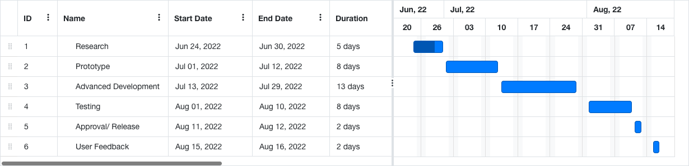

The timeliness will be respected at all costs until unusual circumstances arise that may delay the deadline. In this case, the risk plan should focus on significant improvements, as well as an emphasis on non-essential requirements and meeting deadlines.

I admit that the plan is very ambitious and in the case that unforeseen difficulties arise, the plan will be adjusted to deliver a functional prototype with selected capabilities.

# **References**

Anon., n.d. *Alpaca api.* [Online]   
Available at: https://alpaca.markets/  
[Accessed 26 06 2022].

Anon., n.d. *google finance api.* [Online]   
Available at: https://www.google.com/finance/?hl=en  
[Accessed 26 06 2022].

Anon., n.d. *how to build a trading platform.* [Online]   
Available at: https://agilie.com/blog/how-to-build-a-trading-platform-5-things-to-know-before-you-start-a-stock-market-app-like-e-trade  
[Accessed 27 06 2022].

Anon., n.d. *Paper Trading – How to use stock market simulators for virtual stock trading and backtesting without risking money.* [Online]   
Available at: https://www.lehnerinvestments.com/en/paper-trading-stock-market-simulators-virtual-stock-trading-backtesting-without-risking-money/  
[Accessed 29 06 2022].

Anon., n.d. *Technologies used by othe applications.* [Online]   
Available at: https://www.wappalyzer.com/  
[Accessed 27 06 2022].

Anon., n.d. *yahoo finance api.* [Online]   
Available at: https://finance.yahoo.com/  
[Accessed 26 06 2022].